

23CSE211 – Design and Analysis of Algorithms (DAA)
Week 8 – Huffman Coding

By C S Deeraj
CH.SC.U4CSE24106

The Question Given:
Huffman Coding
Write a C Program to implement Huffman Coding that takes a string as an input and generates Huffman Code for all unique characters in the string.
The string is “DATAANALYTICSANDINTELLIGENCELABORATORY”

C Code:
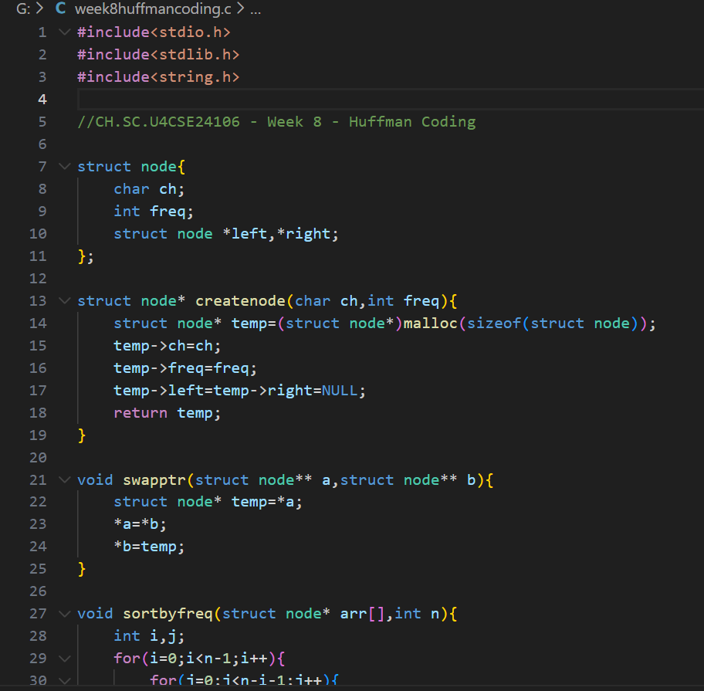
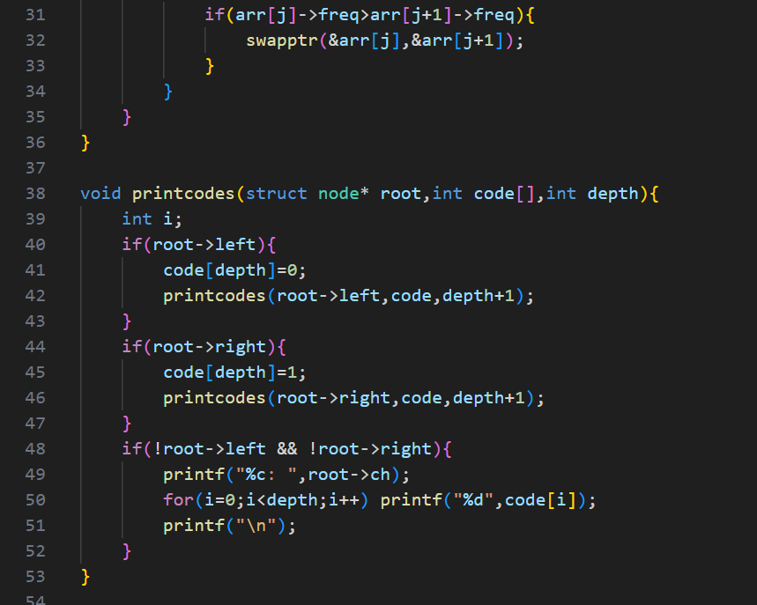
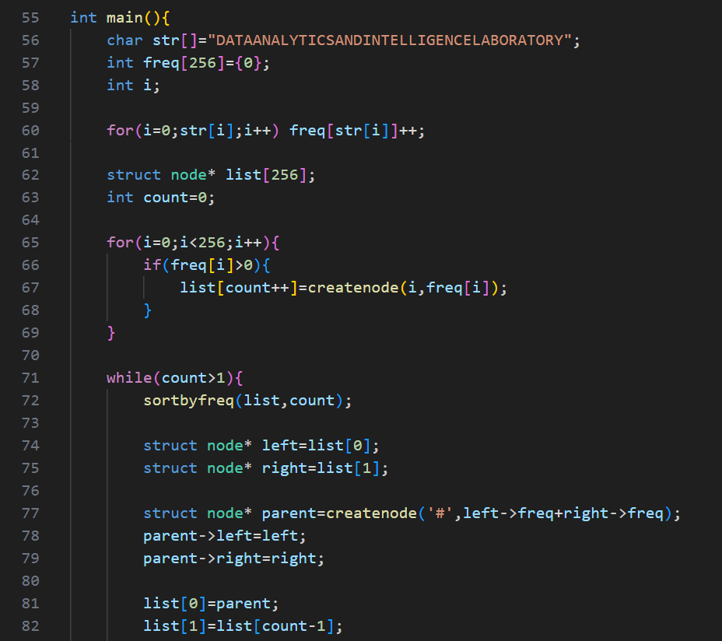
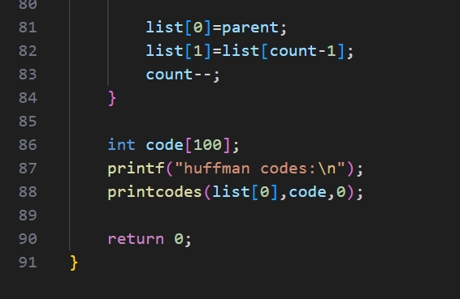
Output:
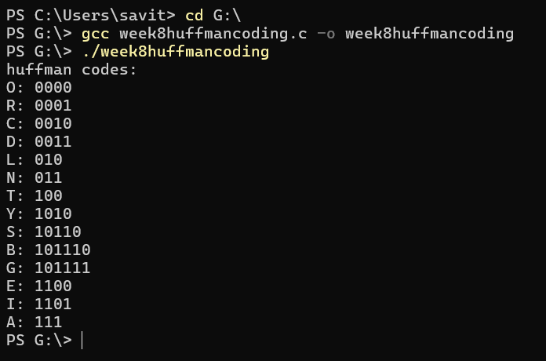

Time Complexity
The time complexity mainly comes from building the Huffman tree. First, we count frequencies which takes O(n) where n is the length of the string. Then we repeatedly sort the list of nodes to pick the two smallest frequencies. Since sorting is done multiple times and each sort takes O(k²) (bubble sort), the overall time goes up to about O(k²), where k is the number of unique characters. So overall it is roughly O(n + k²).
Space Complexity
The space complexity is based on storing the frequency array, node list, and the tree. The frequency array is constant size (256), and the node list/tree stores one node per unique character. So the extra space used is proportional to the number of unique characters, giving O(k).

